**PROJECT REPORT**

**ACADEMIC YEAR 2024 – 25 (ODD)**

**NAME OF THE APPLIED LAB**

**CYBERFORENSICS APPLIED LAB**

**Date: 30/07/2024**

**SIG Team Name: SHINE**

**Student details with register numbers in brackets:**

**Shadha Basheer Ahamed(95072215048)**

**Ashik Habeeb (95072212017)**

**Sakthivel K.  (95072212129)**

**Dharshni (95072212036)**

**Applied Lab Mentor:DR.RAVI**

**TITLE OF THE PROJECT**

**Speech to text conversion for local ethnic languages of MP like Malavi, Bagheli etc.**

**Provide the detail description about the Product**

**Transform spoken words into written text with our Speech-to-Text Conversion tool, designed for the ethnic languages of Madhya Pradesh, including Malavi and Bagheli. Featuring high accuracy, real-time transcription, and an easy-to-use interface, our solution supports education, cultural preservation, and accessibility. Secure and customizable, it's perfect for enhancing communication in regional dialects.**

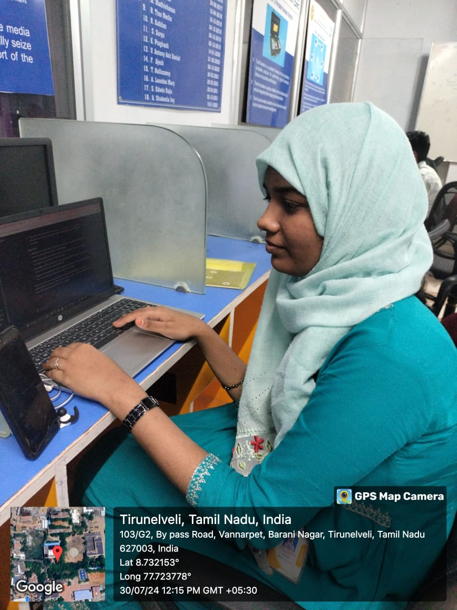

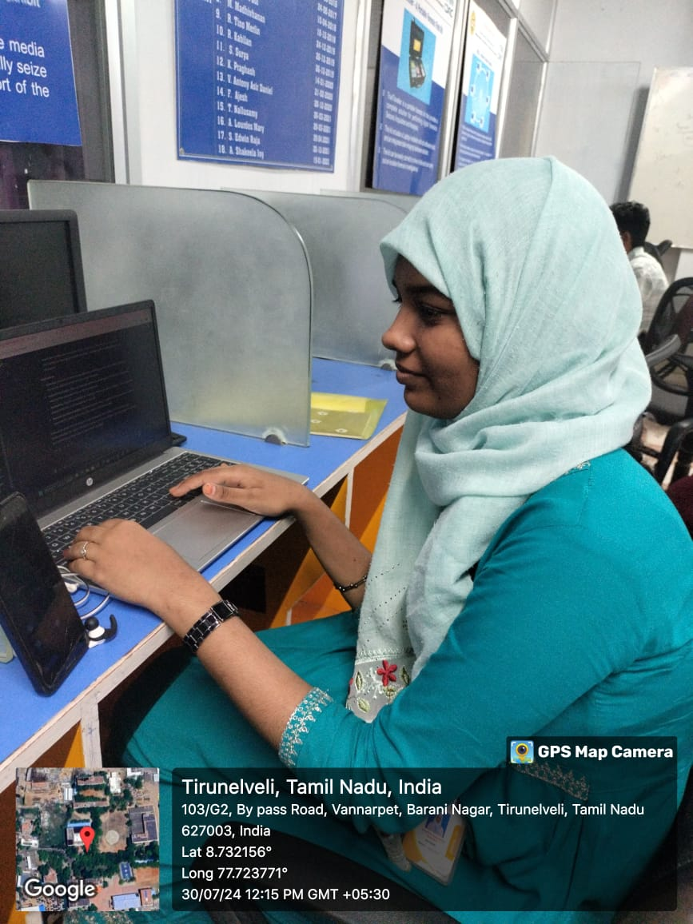

**Lab In – Charge IAL – Vertical Head M – Team Professor**